Вам потрібно розшифрувати слова пов’язані з дефектами фанери . На які потрібно звертати увагу при виборі заготовки для виготовлення виробу.

(*Цифра – порядковий номер букви)*

|  |  |  |  |  |  |  |  |  |  |
| --- | --- | --- | --- | --- | --- | --- | --- | --- | --- |
| **18** | **7** | **21** | **12** | **3** | **18** | **19** | **22** | **23** | **12** |

**2**

**1**

**4**

**4**

**2**

**1**

|  |  |  |  |  |  |  |  |  |
| --- | --- | --- | --- | --- | --- | --- | --- | --- |
| **20** | **19** | **21** | **19** | **9** | **18** | **11** | **18** | **1** |

|  |  |  |  |  |  |  |  |  |  |  |  |
| --- | --- | --- | --- | --- | --- | --- | --- | --- | --- | --- | --- |
| **21** | **19** | **10** | **29** | **1** | **21** | **24** | **3** | **1** | **18** | **18** | **33** |

**3**

|  |  |  |  |  |
| --- | --- | --- | --- | --- |
| **22** | **15** | **19** | **16** | **11** |

Впишіть отримані слова:

|  |  |  |  |  |  |  |  |  |  |
| --- | --- | --- | --- | --- | --- | --- | --- | --- | --- |
|  |  |  |  |  |  |  |  |  |  |

|  |  |  |  |  |  |  |  |  |
| --- | --- | --- | --- | --- | --- | --- | --- | --- |
|  |  |  |  |  |  |  |  |  |

|  |  |  |  |  |  |  |  |  |  |  |  |
| --- | --- | --- | --- | --- | --- | --- | --- | --- | --- | --- | --- |
|  |  |  |  |  |  |  |  |  |  |  |  |

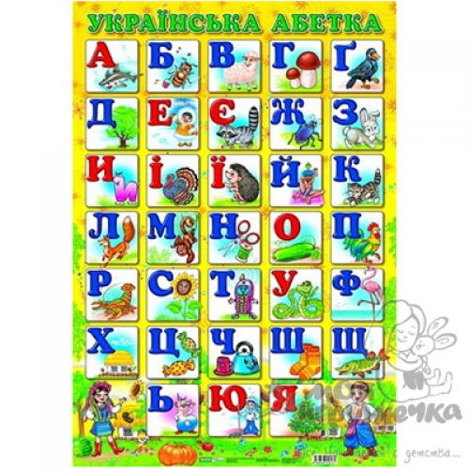

**3**

|  |  |  |  |  |
| --- | --- | --- | --- | --- |
|  |  |  |  |  |